SHIRE OF GINGIN COMMUNITY FUNDING PROGRAM
Public Liability Insurance Contribution: Guidelines
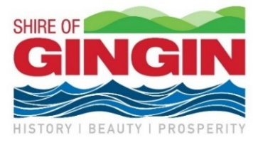

Public Liability Insurance (PLI) is important for groups to have, but it can be expensive. This grant is available to cover 50% of a group’s Public Liability Insurance up to a maximum of $500.

Starting in 2023/24 PLI grants will be approved in three-year cycles. New groups who apply in 2024/25 will be approved for two years, and groups who apply in 2025/26 will be approved for one year.

Who is eligible for funding?
To be eligible for a PLI contribution your group must:
- Be an incorporated not-for-profit based in the Shire
- Have $10 million PLI coverage, or if you lease a Shire building $20 million coverage
- Not be a sporting group or community enterprise or emergency service group.

What does the funding cover?

The grant contributes towards the Public Liability portion of the Insurance Package. It doesn’t include other policies such as Contents Insurance or Association Liability.

How do we apply?
Fill in the application form on pages 2 and 3. Ensure you attach the required documents and read the Funding Agreement prior to signing.

Contact our team with any questions and make sure your application is submitted by 31 March 2024.

When do we find out if we are successful?
We will let you know the outcome of your application by the end of August 2024.

When do we receive the funds?
If your application is successful, you will need to wait until you receive your PLI invoice from your insurance provider during the 2023/24 Financial Year. You can then invoice the Shire for 50%. We understand that there may be slight changes in the amount between the years. Make sure you attached a copy of the bill from your insurers to confirm the amount.

More information
For more information, please contact the Community Services team.
T: (08) 9575 5100
E: grants@gingin.wa.gov.au

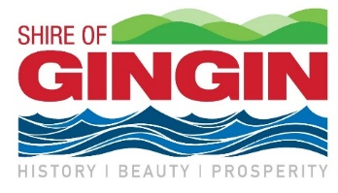

application form
Public Liability Insurance Contribution

1. Application Information
Organisation name:
Sum requested from Shire of Gingin (50% of 2024/25 PLI, GST exclusive):
Postal Address:
Contact person: |  | Role:
Contact number: |  | Email:
ABN: (if applicable) |  |  | GST Registered: Yes No

2. information about your organisation
What is the primary purpose of the group?
How many people receive services directly from your organisation per year?
How many additional people, in the wider community, receive an indirect benefit
from your organisation (per year)?
What year was your organisation established?
Number of members (if relevant):
Who owns the premises from which
you operate your service?

3. APPLICANT CHECKLIST

Copy provided with application:

Most recent Public Liability Insurance Invoice

Most recent financial statement

Insurance Certificates of Currency
Current Certificate of Incorporation (if not supplied previously)

4. Declaration
On behalf of the applicant organisation, I declare that:
- All the information provided is true and correct.
- I give permission to the Shire of Gingin to contact any persons or organisations in the assessment of the application, as appropriate.
- I have read and fully accept Funding Agreement (next page), understanding it will come into effect if this Funding Application is successful.
Applicant Signature: |  | Date:
 | Chairperson/President/Authorised Person
Print Name: |  | Title:
Position:
Witness name:
Witness signature:

Funding Agreement between the Shire of Gingin and the Applicant

The Applicant agrees to:
- Use the funding for the purpose outlined in the approved application or seek a variation in writing from the Shire prior to spending any funds.

- Invoice the Shire for 50% contribution of the Public Liability Insurance renewal invoice (up to a maximum amount of $500) due each Financial Year of the Agreement.

- Include a copy of this Public Liability Insurance renewal invoice from the insurers.

- Comply with Goods and Services Tax (GST) requirements:
  - If the group or organisation is registered for GST, then comply with GST requirements and issue a tax invoice with Australian Business Number (ABN) and GST included in addition to approved funding amount;
  - If the group or organisation is not registered for GST then GST cannot be added onto the approved amount and payment will be made on receipt of an invoice with ABN or invoice with a Statement by Supplier; and
  - GST liability will be remitted to the Australian Taxation Office (ATO).

- Return unspent monies to the Shire if applicable.

The Applicant understands that:

- Failure to adhere to this Funding Agreement may jeopardise the organisation’s future funding opportunities with the Shire.

- This Funding Agreement will end on 31 May 2026 unless by prior written request and agreement.

